Tên: Trần Phương Nam

MSSV: 2172234

LAB 9 Routers

#### Sơ đồ:

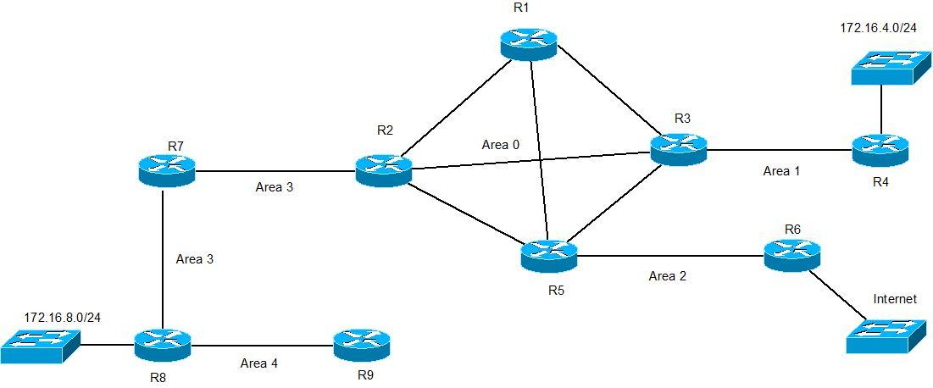

#### Sơ đồ trong GNS3

#### Cấu hình trên Juniper:

---juniper---

#R1

---edit logical-system R1---

set interfaces ge-0/0/3 unit 12 description "connect to R2"

set interfaces ge-0/0/3 unit 12 vlan-id 12

set interfaces ge-0/0/3 unit 12 family inet address 10.1.2.1/24

set interface lo0 unit 100 family inet address 10.0.0.1/32

set interface lo0 unit 100 family iso address 49.0000.0000.1000.0001.00

Set protocols isis interface ge-0/0/3.12

Set protocols isis interface lo0.100

set protocols ospf area 0.0.0.0 interface ge-0/0/3.12

set interfaces ge-0/0/0 unit 13 description "connect to R3"

set interfaces ge-0/0/0 unit 13 vlan-id 13

set interfaces ge-0/0/0 unit 13 family inet address 10.1.3.1/24

Set protocols isis interface ge-0/0/3.13

set protocols ospf area 0.0.0.0 interface ge-0/0/0.13

set interfaces ge-0/0/0 unit 15 description "connect to R5"

set interfaces ge-0/0/0 unit 15 vlan-id 15

set interfaces ge-0/0/0 unit 15 family inet address 10.1.5.1/24

set protocols isis interface ge-0/0/3.15

set protocols ospf area 0.0.0.0 interface ge-0/0/0.15

set routing-options static route 0.0.0.0/0 next-hop 10.1.5.5

commit

#R3

---edit logical-system R3---

set interfaces ge-0/0/3 unit 23 description "connect to R2"

set interfaces ge-0/0/3 unit 23 vlan-id 23

set interfaces ge-0/0/3 unit 23 family inet address 10.2.3.3/24

set interfaces ge-0/0/3 unit 23 family iso

set interface lo0 unit 300 family inet address 10.0.0.3/32

set interface lo0 unit 300 family iso address 49.0000.0000.1000.0003.00

set protocols isis interface ge-0/0/3.12

set protocols isis interface lo0.300

set protocols ospf area 0.0.0.0 interface ge-0/0/3.23

set interfaces ge-0/0/1 unit 13 description "connect to R1"

set interfaces ge-0/0/1 unit 13 vlan-id 13

set interfaces ge-0/0/1 unit 13 family inet address 10.1.3.3/24

set interfaces ge-0/0/1 unit 13 family iso

set protocols isis interface ge-0/0/1.13

set protocols ospf area 0.0.0.0 interface ge-0/0/1.13

set interfaces ge-0/0/0 unit 35 description "connect to R5"

set interfaces ge-0/0/0 unit 35 vlan-id 35

set interfaces ge-0/0/0 unit 35 family inet address 10.3.5.3/24

set interfaces ge-0/0/0 unit 35 family iso

set protocols isis interface ge-0/0/0.35

set protocols ospf area 0.0.0.0 interface ge-0/0/0.35

set interfaces ge-0/0/3 unit 34 description "connect to R4"

set interfaces ge-0/0/3 unit 34 vlan-id 34

set interfaces ge-0/0/3 unit 34 family inet address 10.3.4.3/24

set interfaces ge-0/0/3 unit 34 family iso

set protocols isis interface ge-0/0/3.34

set protocols ospf area 0.0.0.0 interface ge-0/0/3.34

set routing-options static route 0.0.0.0/0 next-hop 10.3.5.5

commit

#R5

---edit logical-system R5---

set interfaces ge-0/0/1 unit 15 description "connect to R1"

set interfaces ge-0/0/1 unit 15 vlan-id 15

set interfaces ge-0/0/1 unit 15 family inet address 10.1.5.5/24

set interfaces ge-0/0/1 unit 15 family iso

set interface lo0 unit 500 family inet address 10.0.0.5/32

set interface lo0 unit 500 family iso address 49.0000.0000.1000.0005.00

set protocols isis interface ge-0/0/1.15

set protocols isis interface lo0.300

set protocols ospf area 0.0.0.0 interface ge-0/0/1.15

set interfaces ge-0/0/3 unit 25 description "connect to R2"

set interfaces ge-0/0/3 unit 25 vlan-id 25

set interfaces ge-0/0/3 unit 25 family inet address 10.2.5.5/24

set interfaces ge-0/0/3 unit 25 family iso

set protocols isis interface ge-0/0/3.25

set protocols ospf area 0.0.0.0 interface ge-0/0/3.25

set interfaces ge-0/0/1 unit 35 description "connect to R3"

set interfaces ge-0/0/1 unit 35 vlan-id 35

set interfaces ge-0/0/1 unit 35 family inet address 10.3.5.5/24

set interfaces ge-0/0/1 unit 35 family iso

set protocols isis interface ge-0/0/1.35

set protocols ospf area 0.0.0.0 interface ge-0/0/1.35

set interfaces ge-0/0/3 unit 56 description "connect to R6"

set interfaces ge-0/0/3 unit 56 vlan-id 56

set interfaces ge-0/0/3 unit 56 family inet address 10.5.6.5/24

set interfaces ge-0/0/3 unit 56 family iso

set protocols isis interface ge-0/0/3.56

set protocols ospf area 0.0.0.0 interface ge-0/0/3.56

set routing-options static route 0.0.0.0/0 next-hop 10.5.6.6

commit

#R7

---edit logical-system R7---

set interfaces ge-0/0/3 unit 27 description "connect to R2"

set interfaces ge-0/0/3 unit 27 vlan-id 27

set interfaces ge-0/0/3 unit 27 family inet address 10.2.7.7/24

set interfaces ge-0/0/3 unit 27 family iso

set interface lo0 unit 700 family inet address 10.0.0.7/32

set interface lo0 unit 700 family iso address 49.0003.0000.1000.0007.00

set protocols isis interface ge-0/0/3.27

set protocols isis interface lo0.700

set protocols ospf area 0.0.0.0 interface ge-0/0/3.27

set interfaces ge-0/0/3 unit 78 description "connect to R8"

set interfaces ge-0/0/3 unit 78 vlan-id 78

set interfaces ge-0/0/3 unit 78 family inet address 10.7.8.7/24

set interfaces ge-0/0/3 unit 78 family iso

set protocols isis interface ge-0/0/3.78

set protocols ospf area 0.0.0.0 interface ge-0/0/3.78

set routing-options static route 0.0.0.0/0 next-hop 10.2.7.2

commit

#R9

---edit logical-system R9---

set interfaces ge-0/0/3 unit 89 description "connect to R8"

set interfaces ge-0/0/3 unit 89 vlan-id 89

set interfaces ge-0/0/3 unit 89 family inet address 10.8.9.9/24

set interfaces ge-0/0/3 unit 89 family iso

set interface lo0 unit 900 family inet address 10.0.0.9/32

set interface lo0 unit 900 family iso address 49.0004.0000.1000.0009.00

set protocols isis interface ge-0/0/3.89

set protocols isis interface lo0.900

set protocols ospf area 0.0.0.0 interface ge-0/0/3.89

set interfaces ge-0/0/3 unit 910 description "connect to R10"

set interfaces ge-0/0/3 unit 910 vlan-id 910

set interfaces ge-0/0/3 unit 910 family inet address 10.9.10.9/24

set interfaces ge-0/0/3 unit 910 family iso

set protocols isis interface ge-0/0/3.910

set protocols ospf area 0.0.0.5 interface ge-0/0/3.910

set routing-options static route 0.0.0.0/0 next-hop 10.8.9.8

Commit

#### Cấu hình trên Cisco

#SW

vlan database

vlan 12

vlan 13

vlan 15

Vlan 111

vlan 23

vlan 25

vlan 27

Vlan 212

vlan 34

vlan 35

vlan 56

vlan 78

vlan 89

Vlan 910

exit

config t

hostname SW

interface f1/2

switchport mode trunk

interface f1/4

switchport mode trunk

interface f1/6

switchport mode trunk

interface f1/8

switchport mode trunk

interface f1/10

switchport mode trunk

interface f1/12

switchport mode trunk

interface f1/15

switchport mode trunk

---R2---

config t

int f0/0

no shutdown

exit

int f0/0.12

encapsulation dot1q 12

ip address 10.1.2.2 255.255.255.0

ip router isis

exit

int f0/0.23

encapsulation dot1q 23

ip address 10.2.3.2 255.255.255.0

ip router isis

exit

int f0/0.25

encapsulation dot1q 25

ip address 10.2.5.2 255.255.255.0

ip router isis

exit

int f0/0.27

encapsulation dot1q 27

ip address 10.2.7.2 255.255.255.0

ip router isis

exit

int f0/0.212

encapsulation dot1q 212

ip address 10.2.12.2 255.255.255.0

exit

router isis

net 49.0000.0000.1000.0002.00

router ospf 1

network 10.1.2.2 255.255.255.0 area 0

network 10.2.3.2 255.255.255.0 area 0

network 10.2.7.2 255.255.255.0 area 3

network 10.2.5.2 255.255.255.0 area 0

network 10.2.12.2 255.255.255.0 area 7

---R4---

config t

int f0/0

no shutdown

exit

int f0/0.34

encapsulation dot1q 34

ip address 10.3.4.4 255.255.255.0

ip router isis

Ip nat inside

Exit

int f0/1

ip add dhcp

ip nat outside

no shut

exit

router ospf 1

Default-information originate

network 10.3.4.4 255.255.255.0 area 1

router isis

ret 49.0001.0000.1000.0004.00

---R6---

config t

int f0/0

no shutdown

exit

int f0/0.56

encapsulation dot1q 56

ip address 10.5.6.6 255.255.255.0

ip router isis

ip nat inside

exit

int f0/1

ip add dhcp

ip nat outside

no shut

exit

ip nat inside source list 1 int fa0/1 overload

access-list 1 permit 10.1.5.0 0.0.0.255

access-list 1 permit 10.2.5.0 0.0.0.255

access-list 1 permit 10.2.7.0 0.0.0.255

access-list 1 permit 10.3.4.0 0.0.0.255

access-list 1 permit 10.3.5.0 0.0.0.255

access-list 1 permit 10.5.6.0 0.0.0.255

access-list 1 permit 10.7.8.0 0.0.0.255

access-list 1 permit 10.8.9.0 0.0.0.255

router ospf 1

Default-information originate

network 10.5.6.6 255.255.255.0 area 2

---R8---

config t

int f0/0

no shutdown

exit

int f0/0.89

encapsulation dot1q 89

ip address 10.8.9.8 255.255.255.0

ip router isis

exit

int f0/0.78

encapsulation dot1q 78

ip address 10.7.8.8 255.255.255.0

ip router isis

exit

router isis

net 49.0001.0000.1000.0004.00

router ospf 1

network 10.8.9.8 255.255.255.0 area 4

network 10.7.8.8 255.255.255.0 area 3

---R10---

config t

int f0/0

no shutdown

exit

int f0/0.910

encapsulation dot1q 910

ip address 10.9.10.10 255.255.255.0

ip router isis

Exit

router isis

net 49.0001.0000.1000.0004.00

router ospf 1

network 10.9.10.10 255.255.255.0 area 5

---R12---

config t

int f0/0

no shutdown

exit

int f0/0.212

encapsulation dot1q 212

ip address 10.2.12.12 255.255.255.0

Exit

router ospf 1

network 10.2.12.12 255.255.255.0 area 7

#### Kết quả: Ping R6 -> R8 (Cisco to Cisco)

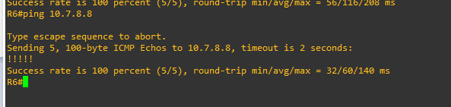

**Ping R3 -> R9 (Juniper to Juniper)**

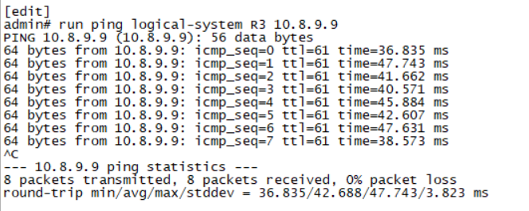

**Ping R4 -> R9 (Cisco to Juniper)**

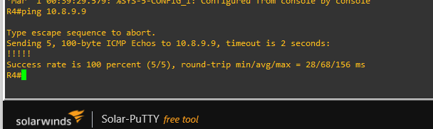

**Ping R9 -> R4 (Juniper to Cisco)**

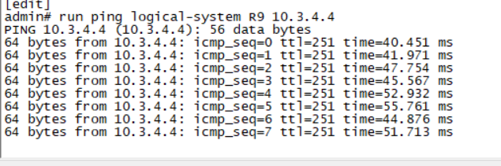

**Ping Cisco (R8)-> Internet**

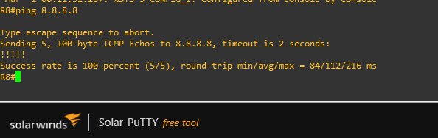

**Ping Juniper (R9) -> Internet**

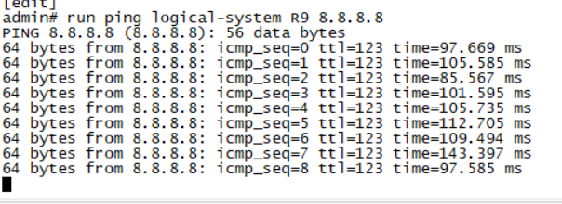

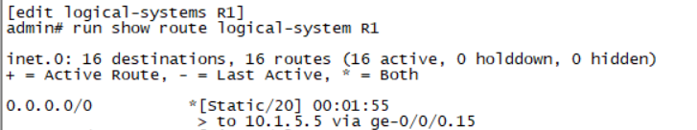

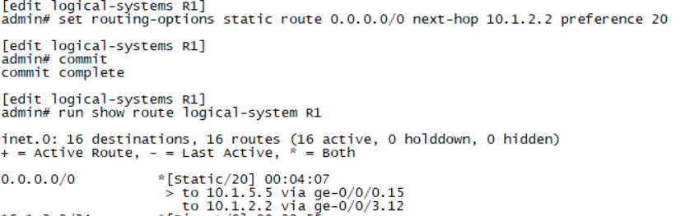

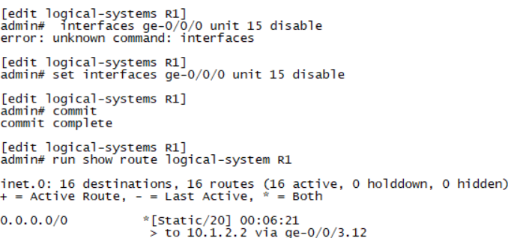

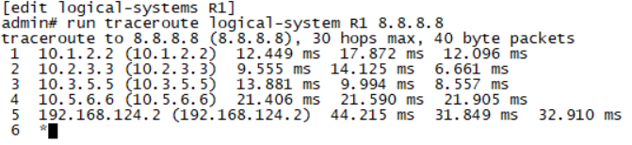

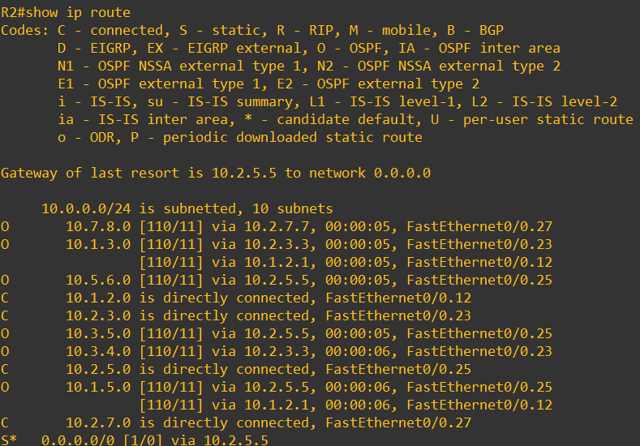

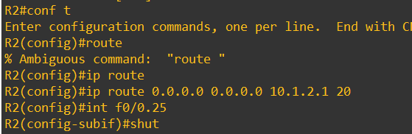

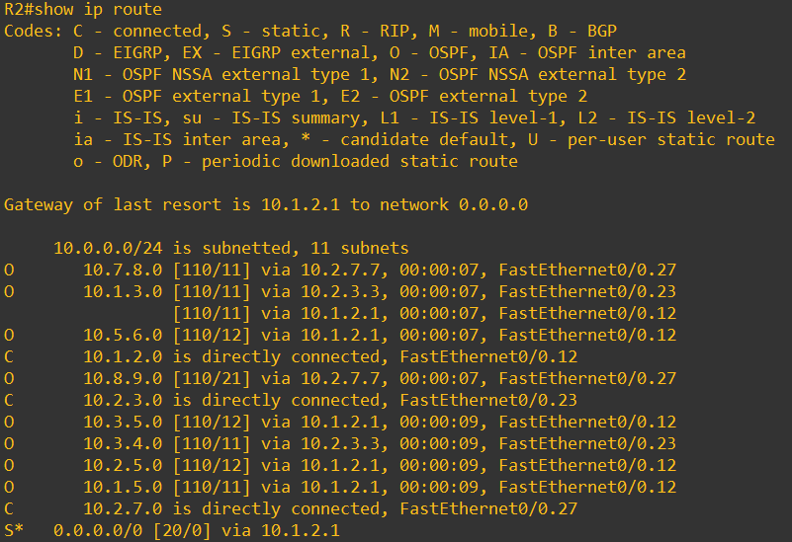

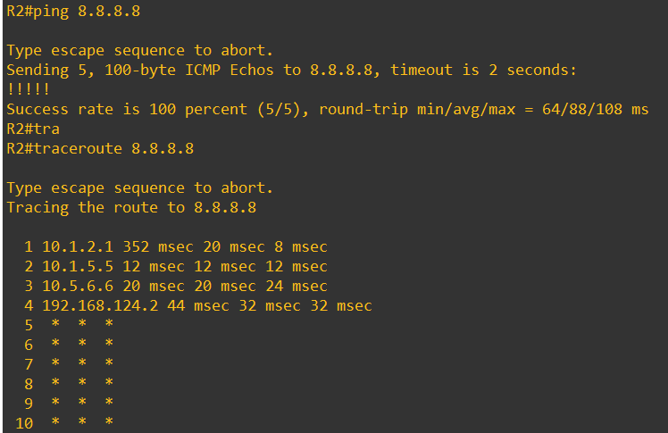

**Tuan 6:**

-Delete static route trên các router.

-Quảng bá default-route trên R6.

-Thay đổi các area trên các router tương ứng

-Tạo loopback trên các router và set router id.

#R1

set interfaces lo0 unit 100 family inet address 10.0.0.1/32

set protocols ospf area 0.0.0.0 interface lo0.100

set routing-options router-id 10.0.0.1

#R3

set interfaces lo0 unit 300 family inet address 10.0.0.3/32

set protocols ospf area 0.0.0.0 interface lo0.300

set routing-options router-id 10.0.0.3

#R5

set interfaces lo0 unit 500 family inet address 10.0.0.5/32

set protocols ospf area 0.0.0.0 interface lo0.500

set routing-options router-id 10.0.0.5

#R7

set interfaces lo0 unit 700 family inet address 10.0.0.7/32

set protocols ospf area 0.0.0.3 interface lo0.700

set routing-options router-id 10.0.0.7

#R9

set interfaces lo0 unit 900 family inet address 10.0.0.9/32

set protocols ospf area 0.0.0.4 interface lo0.900

set routing-options router-id 10.0.0.9

#R2

int loop0

ip add 10.0.0.2 255.255.255.255

router ospf 1

router-id 10.0.0.2

network 10.0.0.2 0.0.0.0.0 area 0

#R4

int loop0

ip add 10.0.0.4 255.255.255.255

router ospf 1

router-id 10.0.0.4

network 10.0.0.4 0.0.0.0 area 1

#R6

int loop0

ip add 10.0.0.6 255.255.255.255

router ospf 1

router-id 10.0.0.6

network 10.0.0.6 0.0.0.0 area 2

#R8

int loop0

ip add 10.0.0.8 255.255.255.255

router ospf 1

router-id 10.0.0.8

network 10.0.0.8 0.0.0.0 area 3

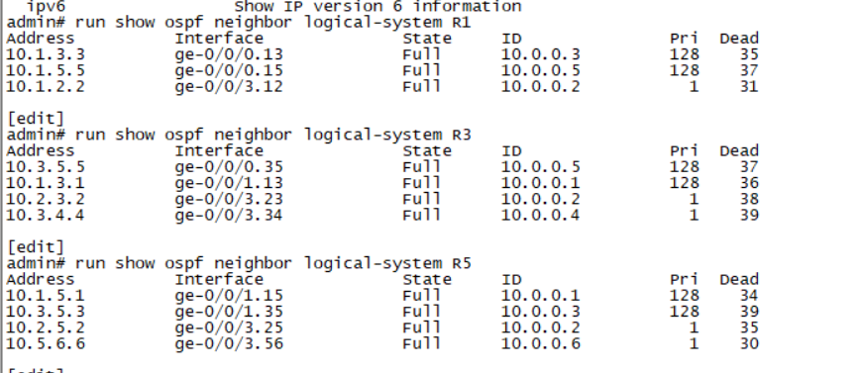

Show Ospf neighbor of Juniper.

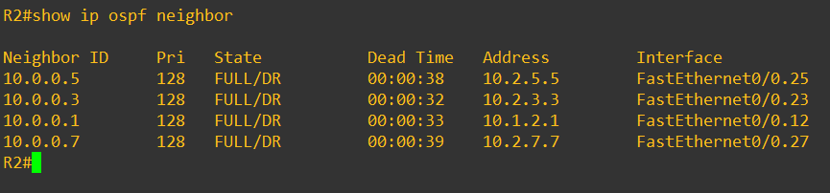

Show ospf neighbor of Cisco R2

**Tuan 7:**

Virtual Link

Stub

**-**Thêm router 10, 11, 12

R9 nối R10: area 5

R1 nối R11: area 6

R2 nối R12: area 7

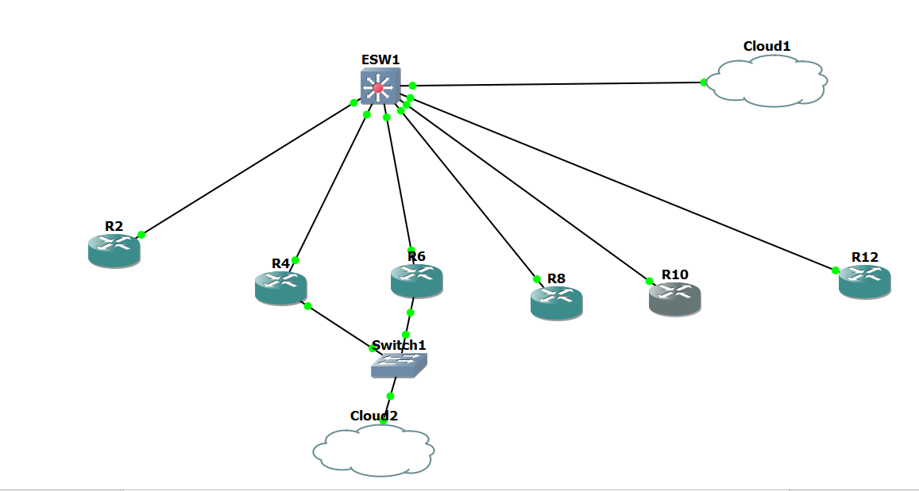

**-Cấu hình virtual link giữa R2-R8**

#R2

(config-router)# area 3 virtual-link 10.0.0.8

#R8

(config-router)# area 3 virtual-link 10.0.0.2

Trước khi cấu hình virtual link R2-R8 trên Router R2, Không có đường đi đến R9 do khác vùng nên ping không được.

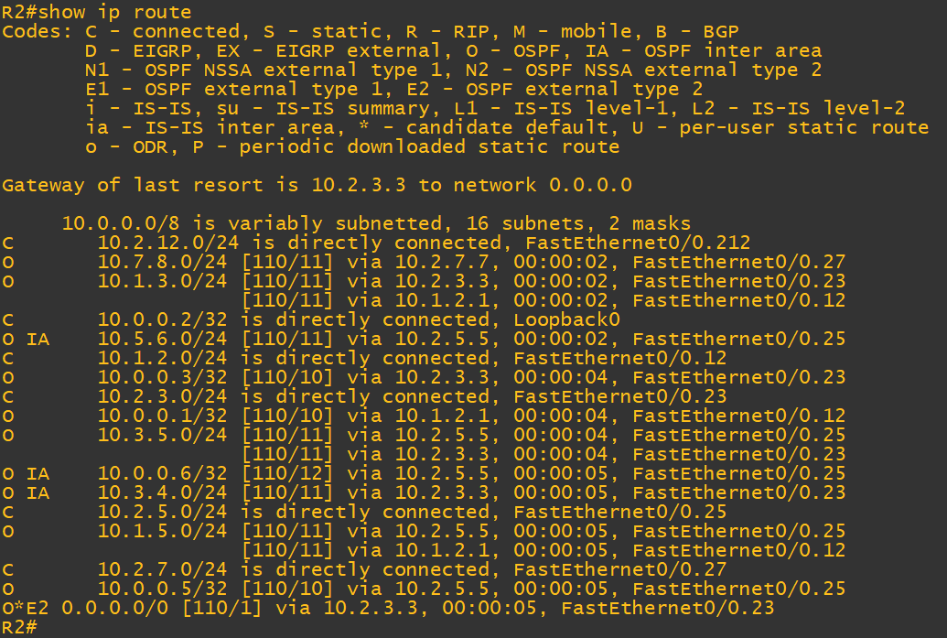

Sau khi cấu hình virtual link R2-R8 trên Router R2, có đường đi đến R9 do có virtual link nên ping được.

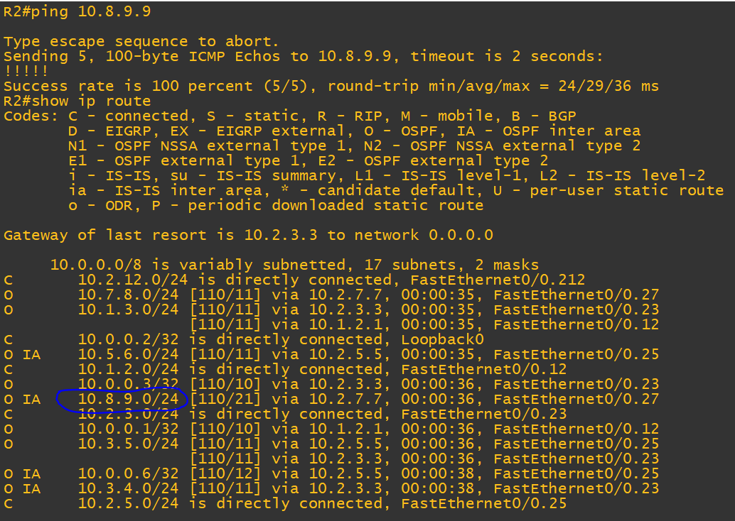

Trước khi cấu hình virtual link R8-R9 trên Router R10

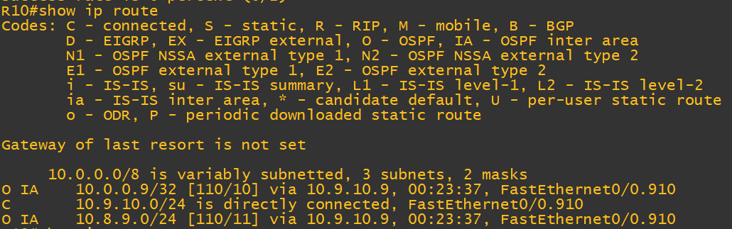

Sau khi cấu hình virtual link R8-R9 trên Router R10

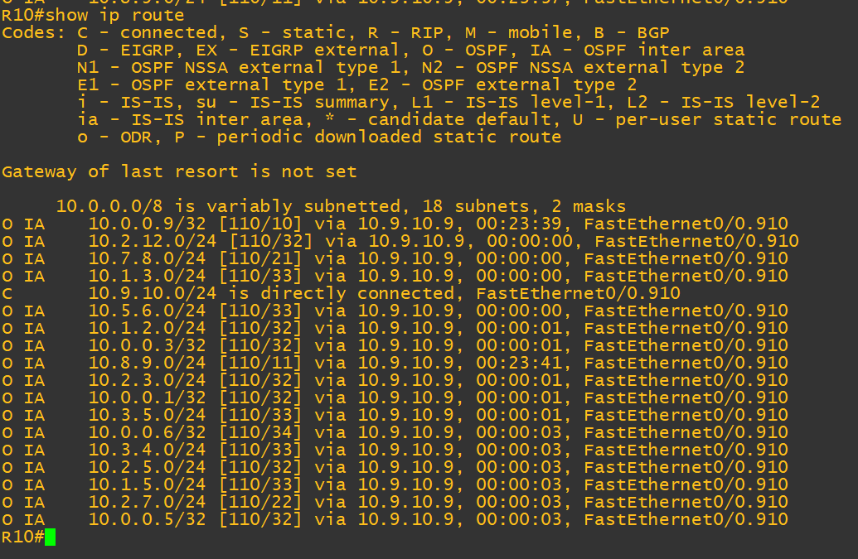

R12

Cấu hình R12, R2 stub

#R12

(config-router)# area 7 stub

#R2

(config-router)# area 7 stub

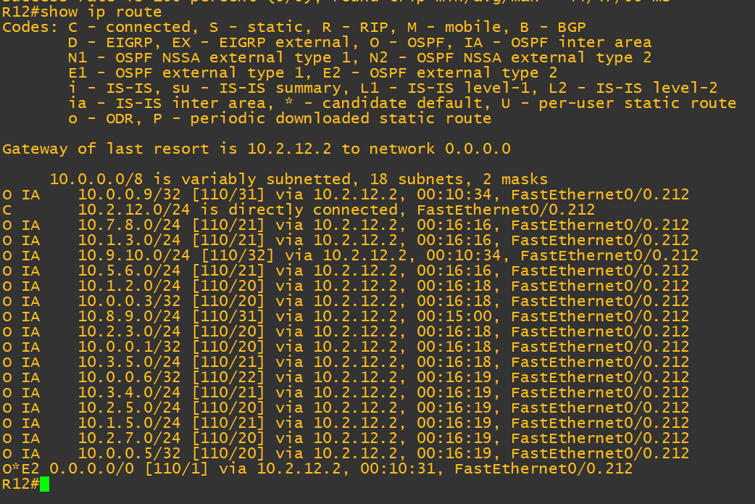

Default route trên bảng routing R12

R2

(config-router)# area 7 stub no-summaries

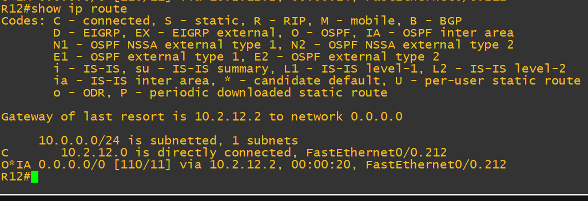

Bảng routing trên R12

🡪Bảng routing trên R12 đã được thu gọn.